**Abstract**

Historical events across the regions for last 2000 years seem to have correlation with climate change. The global temperature data has been shown to have influence over the dynastic change in the history of human civilization. The sun has been shown to be a climate driver in different experiments. The fourier spectrum of our event data shows the strongest components as 405 yr, 150 yr, 101 yr.

The combined global temperature from different proxies have shown the strongest component as ~1000 yr, ~460 yr, and ~190 yr periods. This shows some lag with the cultural event cycle our analysis has shown.

Fourier spectral analysis has shown cyclicity or periodicity in nature in different scientific studies. The sun and the earth are dissipative system with energy input. When the energy input into a dissipative system is increased beyond the range of static stability.

Periodic or cyclic behaviour is so common in nature and physics that it gives the analysis technique of Fourier transform its outstanding importance. The reason for the abundance of cycles lies in the property of the transition from static to dynamic behaviour. This “modulational instability” occurs in space and time when the energy input into a dissipative system is increased beyond the range of static stability [1]. It leads overwhelmingly to a periodic state (rare exceptions exist, e.g. the Lorenz model, where the onset of dynamics is chaotic). The Sun and the Earth are classic dissipative systems with energy input. Cyclic dynamics is therefore to be expected. Cycles with periods ranging from several

Urbanization leads to a profound transformation of the countryside and, hence, to a shift in local climate. The construction of buildings, paving of streets, sealing of areas and reduction of vegetation are important aspects. Among other consequences, these changes result in decreasing wind speeds, less evapotranspiration, and increasing uptakes of solar radiation. All of the mentioned factors cause a rise in temperatures compared to the rural surroundings of a city, generating the so called Urban Heat Island (UHI). In order to study various aspects of the urban climate, we have different research approaches which are explained in the following.

**Materials and methods**

**Results and discussions**

**Causal Model**

Climate change causes the changes in human activities by displacing people from one region to another. Several studies have tried to build model between the connection between climate change and migration. We know that

The history of agricultural activities is very old. Since the beginning of time, human beings were involved in producing diverse range of crops based on the nature of the productivity in the soil of that regions. We have literally transformed the surface of the planet for our own use by making farmlands. Studies show that 12% of our land surface is used for cultivation and another 22% is used for pastures and rangelands (Billie et al 2014 – Geographic distribution of major crops). Global distribution of crops show our dependency on cereals, tubers, sugar crops, pulses, oil-bearing crops, fiber crops. Agricultural industry over time had to maintain a strong network of production and transportation of the crops. It’s very easy to see how the crop production and transportation can be disturbed by major natural calamities. Temperature proxies can be a good indicator to show the climate change throughout the human history. Historical data of Northern hemisphere tree ring and grain yield and agricultural index have shown the disturbance of bio-productivity due to climate change. Changes in bio-productivity affect the food supply per capita which is reflected in grain price and wage index. The unavailability in the supply of food can cause famine which may consequently cause social unrest and disturbance through political changes. Sometimes war may be caused. All these different factors may cause migration of a lot of people. Eventually various cultural events may be occurring due to climate change.

**Conclusion**

Cultural Event frequency

Forcing by solar activity, relationship with temperature

Other relevant cycles

Cross correlation between time series

**Data**:

Frequency of Events in the last 2000 years.

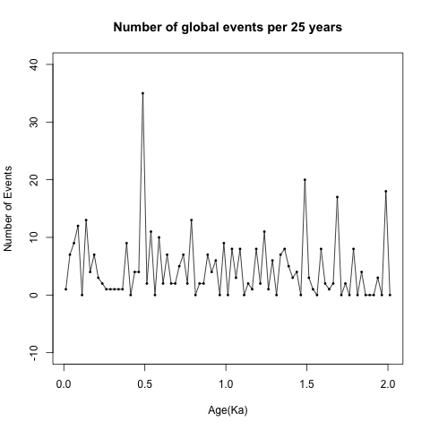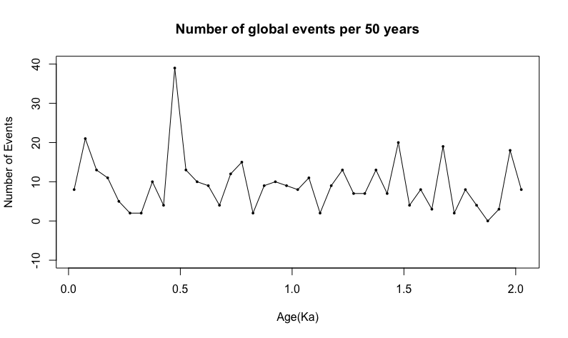

Frequency of Events in the last 5000 years and then for the whole Holocene epoch. But events are clustered in the nearest thousands like (3Ka, 4Ka, 5Ka) which are misleading.

Analysis on the event frequency data from last 2000 years.

Data Processing: Convert the non-stationary event number time series to a weak stationary time series(mean and autocovariance does not change with time) to further do cycle analysis.

1. Demean
2. Filtering with Hanning moving average
3. Detrending (residuals from linear regression)
4. Tapering
5. Hanning smoothing of power spectra

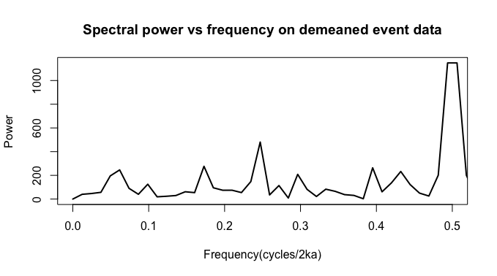

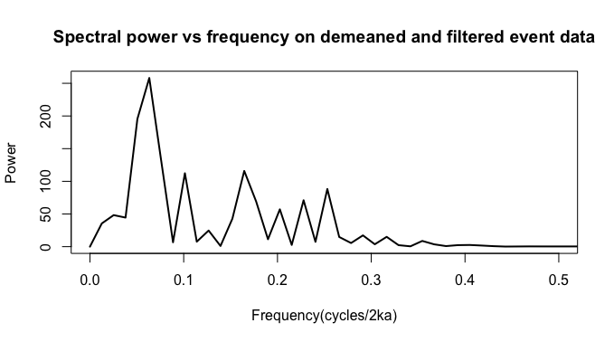

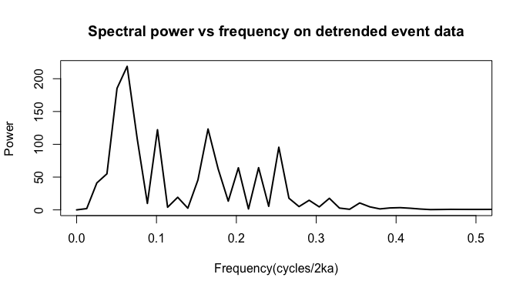

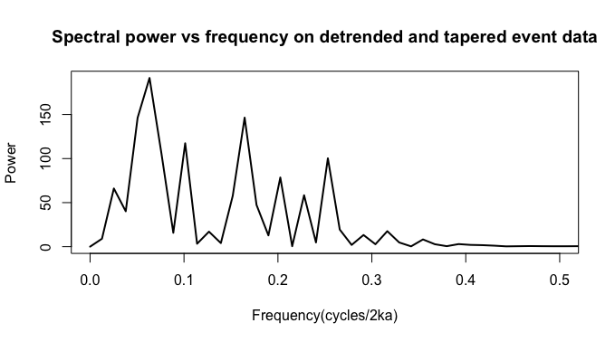

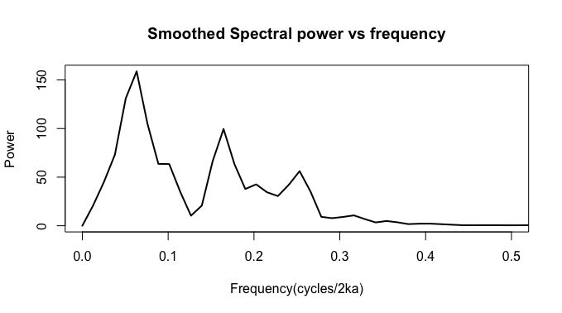

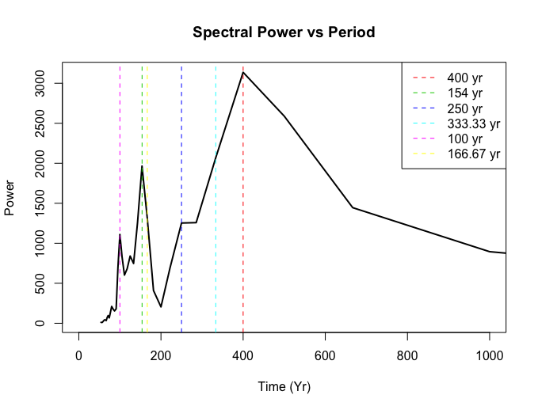

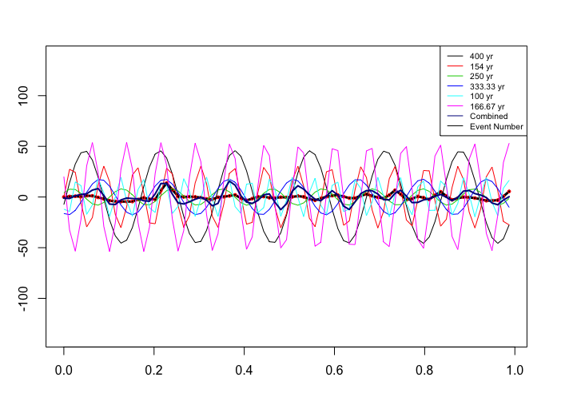

|  |  |  |  |  |
| --- | --- | --- | --- | --- |
| **# Cycles** | **Frequency** | **Period** | **Amplitude** | **Power** |
| 6 | 0.06329114 | 400.0000 | 122.99625 | 158.83075 |
| 14 | 0.16455696 | 153.8462 | 107.57012 | 99.50760 |
| 5 | 0.05063291 | 500.0000 | 107.54739 | 131.11470 |
| 9 | 0.10126582 | 250.0000 | 96.29151 | 63.44699 |
| 7 | 0.07594937 | 333.3333 | 91.47636 | 104.76960 |
| 21 | 0.25316456 | 100.0000 | 89.00611 | 56.19316 |
| 17 | 0.20253165 | 125.0000 | 78.75561 | 42.57242 |
| 3 | 0.02531646 | 1000.0000 | 72.24159 | 45.31505 |
| 19 | 0.22784810 | 111.1111 | 67.90576 | 30.50830 |
| 13 | 0.15189873 | 166.6667 | 67.54380 | 66.50646 |

The top 10 frequency and periods shown in the event frequency data.

|  |  |  |  |
| --- | --- | --- | --- |
| **# Cycles** | **Frequency** | **Power** | **Period** |
| 5 | 0.0625 | 45.40252 | 405.0633 |
| 4 | 0.05 | 35.09184 | 506.3291 |
| 14 | 0.175 | 31.08893 | 144.6655 |
| 8 | 0.1 | 29.57111 | 253.1646 |
| 20 | 0.25 | 27.1028 | 101.2658 |
| 6 | 0.075 | 24.99689 | 337.5527 |
| 2 | 0.025 | 21.18668 | 1012.6582 |
| 18 | 0.225 | 19.44715 | 112.5176 |
| 13 | 0.1625 | 17.98304 | 155.7936 |
| 12 | 0.15 | 12.357 | 168.7764 |

Using periodogram of R (spec.pgram) gives pretty close answer. Power values are different due to normalization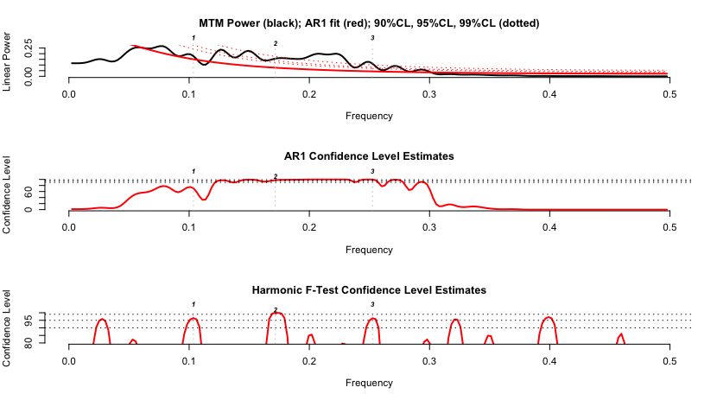

Frequency Harmonic\_CL period

2 0.0625000 0.9803090 405.0633

4 0.1679688 0.9899981 150.7212

5 0.2500000 0.9685964 101.2658

Evolutive Harmonic Analysis



Northern Hemisphere Temperature Data

Christiansen and Ljungqvist [52]: stack of different temperature proxies [°C], extracted from 91 single records, ~30% of them covering the total period, 0 to 1973 AD, 1 year time resolution, northern hemisphere.

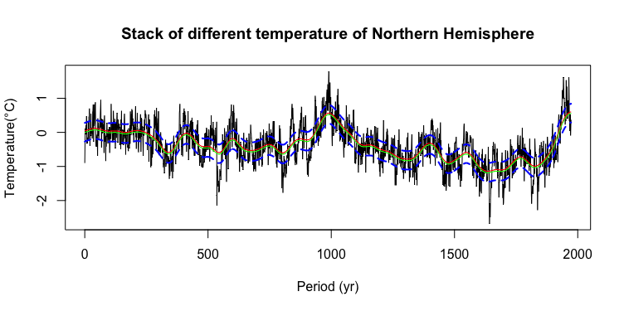

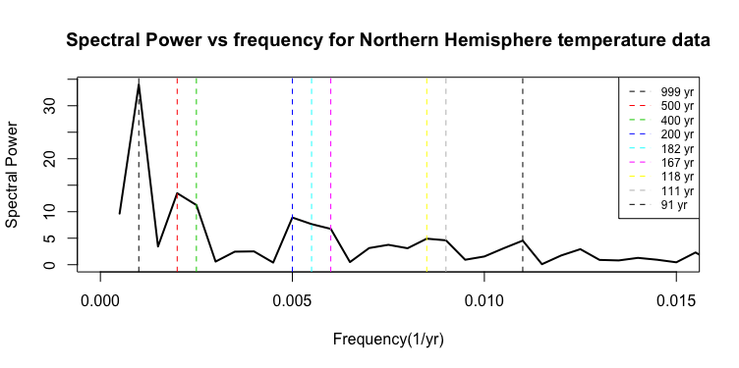

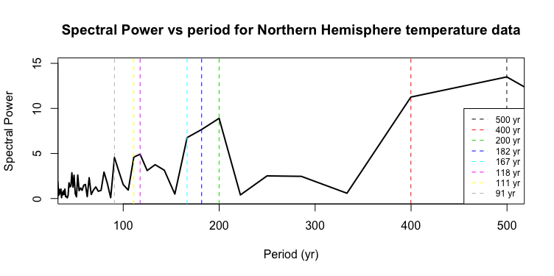

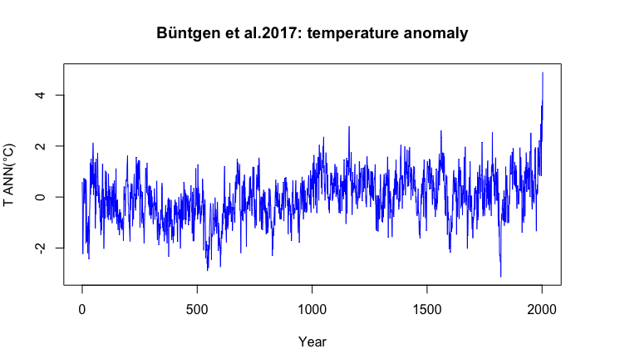

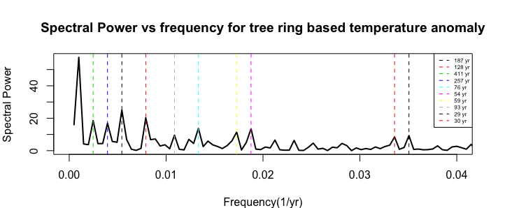

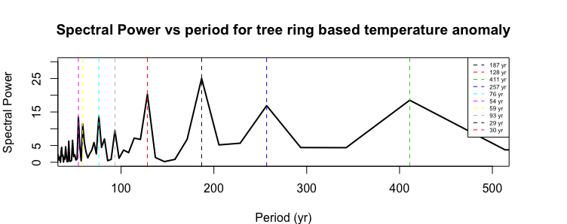

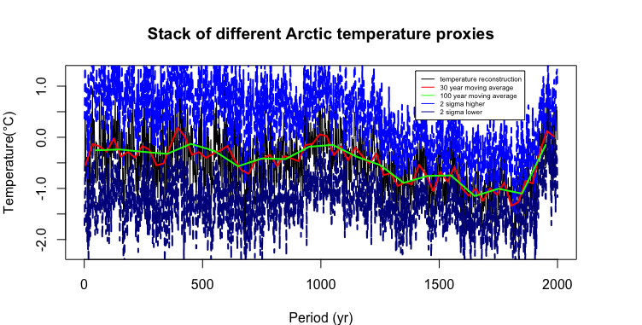

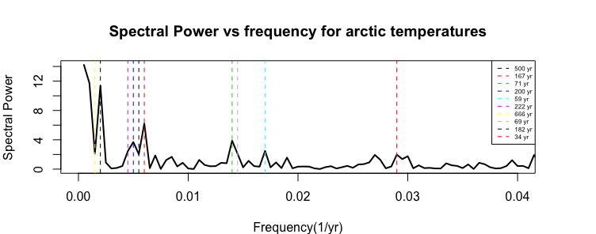

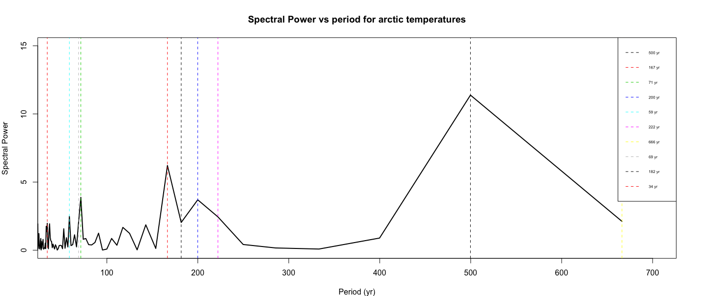

Events in Africa during last 2 thousand years.



Events in the region of East Asia and Oceania during last 2 thousand years.

tscreator_output/Global_event_numbers_50_yr_bin_East_Asia_Oceania_from_0_to2ka.pdf

Events in Middle eastern and Indian region during last 2 thousand years. However, the Indian region events are missing many details of the history of Indian subcontinent.

tscreator_output/Global_event_numbers_50_yr_bin_Middle_East_India_from_0_to2ka.pdf

Events in the region of East Asia and Oceania during last 2 thousand years.

**tscreator_output/Global_event_numbers_50_yr_bin_East_Asia_Oceania_from_0_to2ka.pdf**

Events in European region during last 2 thousand years.

tscreator_output/Global_event_numbers_50_yr_bin_Eastern_Mediterranean_from_0_to2ka.pdf

**Left**: Events in Arctic and Sub-arctic regions during last 2 thousand years. **Right**: Events in Northwest and Canada during last 2 thousand years.

tscreator_output/Global_event_numbers_50_yr_bin_Arctic_Subarctic_from_0_to2ka.pdf tscreator_output/Global_event_numbers_50_yr_bin_Northwest_Canada_from_0_to2ka.pdf

Events in North American region during last 2 thousand years.

tscreator_output/Global_event_numbers_50_yr_bin_North_America_from_0_to2ka.pdf

Events in Middle and South American region during last 2 thousand years.

tscreator_output/Global_event_numbers_50_yr_bin_Middle_South_America_from_0_to2ka.pdf

**Reference:**

1. Christiansen B, Ljungqvist FC. The extra-tropical Northern Hemisphere temperature in the last two millennia: reconstructions of low- frequency variability. Clim Past 2012; 8: 765-786. Data available at ftp://ftp.ncdc.noaa.gov/pub/data/paleo/contributions\_by\_author/ christiansen2012/christiansen2012.txt 2017. (last access: April).
2. Büntgen U, Tegel W, Nicolussi K, et al. 2500 years of European climate variability and human susceptibility. Science 2011; 331: 578-582. Data available at ftp://ftp.ncdc.noaa.gov/pub/data/paleo/treering/reconstructions/europe/buentgen2011europe.txt. 2017. (last access: April)
3. McKay NP, Kaufmann DS. An extended Arctic proxy temperature database for the past 2,000 years. Sci Data 2014; 1(140026). Data available at http://ncdc.noaa.gov/paleo/study/16973 2017. (last access: April).
4. Villalba R, Boninsegna JA, Masiokas M, et al. Large-Scale Temperature Changes Across the Southern Andes: 20th -Century Variations in the context of the Past 400 Years. Climatic Change 2003; 59: 177-232. Data available at: ftp://ftp.ncdc.noaa.gov/pub/data/paleo/treering/ reconstructions/southamerica/patagonia-temperature.txt 2017. (last access: April).
5. Kantelhardt JW, Koscielny-Bunde E, Rego HH, Havlin S, Bunde A. Detecting long-range correlations with detrended fluctuation analysis. Physica A 2001; 295: 441-54. [http://dx.doi.org/10.1016/S0378-4371(01)00144-3]